Solar Hot Water

Today, most homes use natural gas or electricity to heat water for showers and other things. But we can also use the Sun!

How it works: The basic idea behind the most common type of a solar hot water system is shown below. Here, water is circulated through a solar hot water collector. This kind of collector is often called a “flat plate collector”. In this system, some water goes around and around in “closed loop” fashion to collect the solar heat. The collector itself is just a glass-covered box, which is insulated around the sides and on the back. Inside are black colored water pipes with black metal fins. Sunlight is absorbed by the black pipes and fins and makes the water in the pipes hot. The heated water is then circulated through a “heat exchanger” inside a hot water storage tank. The heat exchanger allows the heat to be transferred to the water in the tank without mixing the water in the “solar loop” together with the water in the tank that’s used by people.

Freeze Protection: Because the water that circulates through the solar loop does not mix with the water in the tank, anti-freeze (glycol) can be added to the water in the solar loop to keep the water in the collector from freezing on cold nights, which would otherwise destroy the collector. Because the water in the “solar loop” just goes around and around, this type of system is called a “closed loop” system. It is the most common in the US today.

There are other types of designs that don’t use antifreeze or a heat exchanger. In one type, the hot water from the solar loop goes directly into the water tank and is used by people. If there is any possibility of freezing, then these systems must allow the water in the panel to drain back into the tank when there’s no Sun. These systems are called “drain back systems”. They are somewhat tricky to install correctly, because the water in the collector must always drain out correctly.

Active versus Passive Solar: Solar Systems like the one shown above are called “active solar” because they use a pump to move the water around. Passive solar energy systems doesn’t use any pumps. Some solar hot water systems are passive: They use the “thermosiphoning effect”, where hot water tends to rise. Others function as water “pre-heaters” (see below). Homes that just use windows to let solar heat in are also called “passive”. Passive systems can’t break down there is no pump!

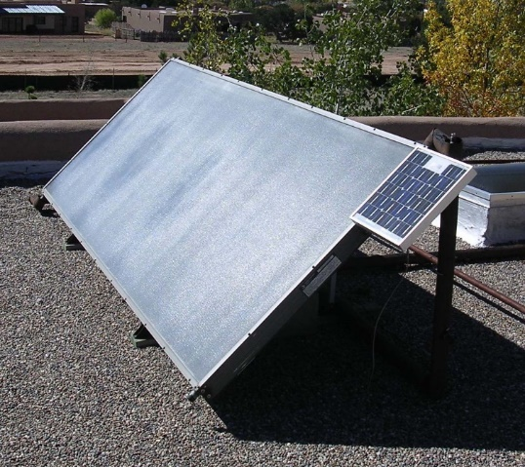
Example System: A solar hot water panel (a flat plate collector) is shown at right. Notice that there is a small PV panel mounted to the upper right hand corner of this panel. This PV panel powers the pump for the hot water panel. That way the pump only runs when solar energy is available, and the electricity used also doesn’t create pollution. Also, if the power grid goes down, the solar hot water system still works!

One solar hot water panel like this provides enough solar heat to heat up one 80-gallon water tank each day in New Mexico – about enough for the average family to take showers and wash the dishes once.

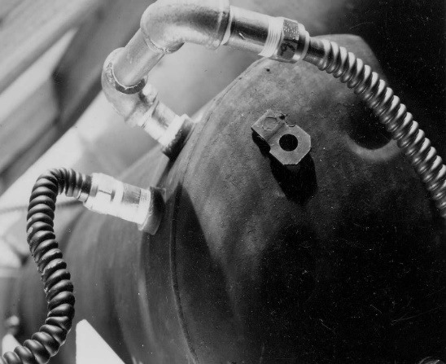
Example System: Another type of solar hot water collector is shown at right. In this case, the collector is just a black painted water tank that sits in a brightly lit window. The tank has insulation behind it to help keep the tank hot. This kind of solar hot water collector is called a “batch collector”, because it has a big “batch” of water in its tank. This kind of system is often used as a simple “pre-heater”, in which case the cold water pipe that normally goes first to a regular hot water tank is simply re-directed to first go through the batch collector, thereby pre-heating the water, before it flows into the regular hot water tank. This decreases the need to use other energy to heat the water in the regular water tank.

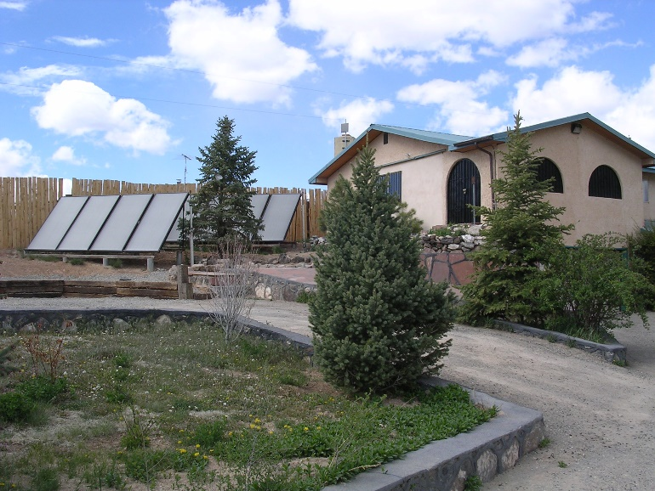
Heating a Whole House with Solar Hot Water: Many flat plate collectors can be used together to heat an entire house, as shown at right. In this case, the solar hot water can be stored in a very large tank for nighttime, or run through pipes underneath the floor to make the floor warm. Heating the floor in this way is called “radiant floor heating”, and it creates a very comfortable home, and also uses the solar heat very efficiently. If the pipes are embedded in cement, then the “thermal mass” of the cement provides “thermal storage”, so that a separate hot water storage tank is not needed, which decreases cost. Thermal mass and thermal storage are also important concepts for “passive solar design”, which is studied in the next section.

It takes at least six solar hot water panels like that shown above to heat a 2000 square foot house.

Rule of Thumb: In general, the panels need to have a total area equal to about 10% of the floor area, unless the house also has lots of “passive solar gain” from large south-facing windows.

Other components: There are many other components besides the hot water panel. These include various types of valves, piping, pipe insulation, a rack to hold the panels, pumps, thermostats, electronic controls, special pressure control tanks (to keep the pressure in the system at a constant value), etc.

Cost: A single flat plate collector (by itself, uninstalled), costs around $800. All the components together for a single panel system typically costs $2000 or more, especially if a new hot water tank is included. Today, one can buy tanks that are designed especially for solar hot water systems that cost more than a regular tank, but are much more durable and better insulated. Much of the cost of a solar hot water system is also for labor: It takes some work to install panels on the roof, and solder all the piping together. A single panel system that heats a standard 80-gallon water tank may cost anywhere from $4000 to $8000. A big system that heats a whole house may cost anywhere from $10,000 to $40,000, depending on the size of the house and the system, whether it has a large storage tank (or a radiant floor heating system instead). Cost also depends on how sophisticated the system is: Some systems are very elaborate, with lots of controls and integration with a back up boiler, etc, while others are very simple.

